CIS 4911 – Senior Project
Tractouch's iBLESS
User Manual

Team Members: Luis Miguel Carrillo
Mentor: Jaime Borras
04/26/2015
COPYRIGHTS AND TRADEMARK INFORMATION

This work is entirely done by Luis Miguel Carrillo unless written otherwise.

Note: this user manual is intended to show the usage of the web services for the android application. Since I have no access to the application due to the unavailability, I have to simulate it using visual studio.

Register SPL

Run PhoneServices.asmx.cs and select Register SPL.

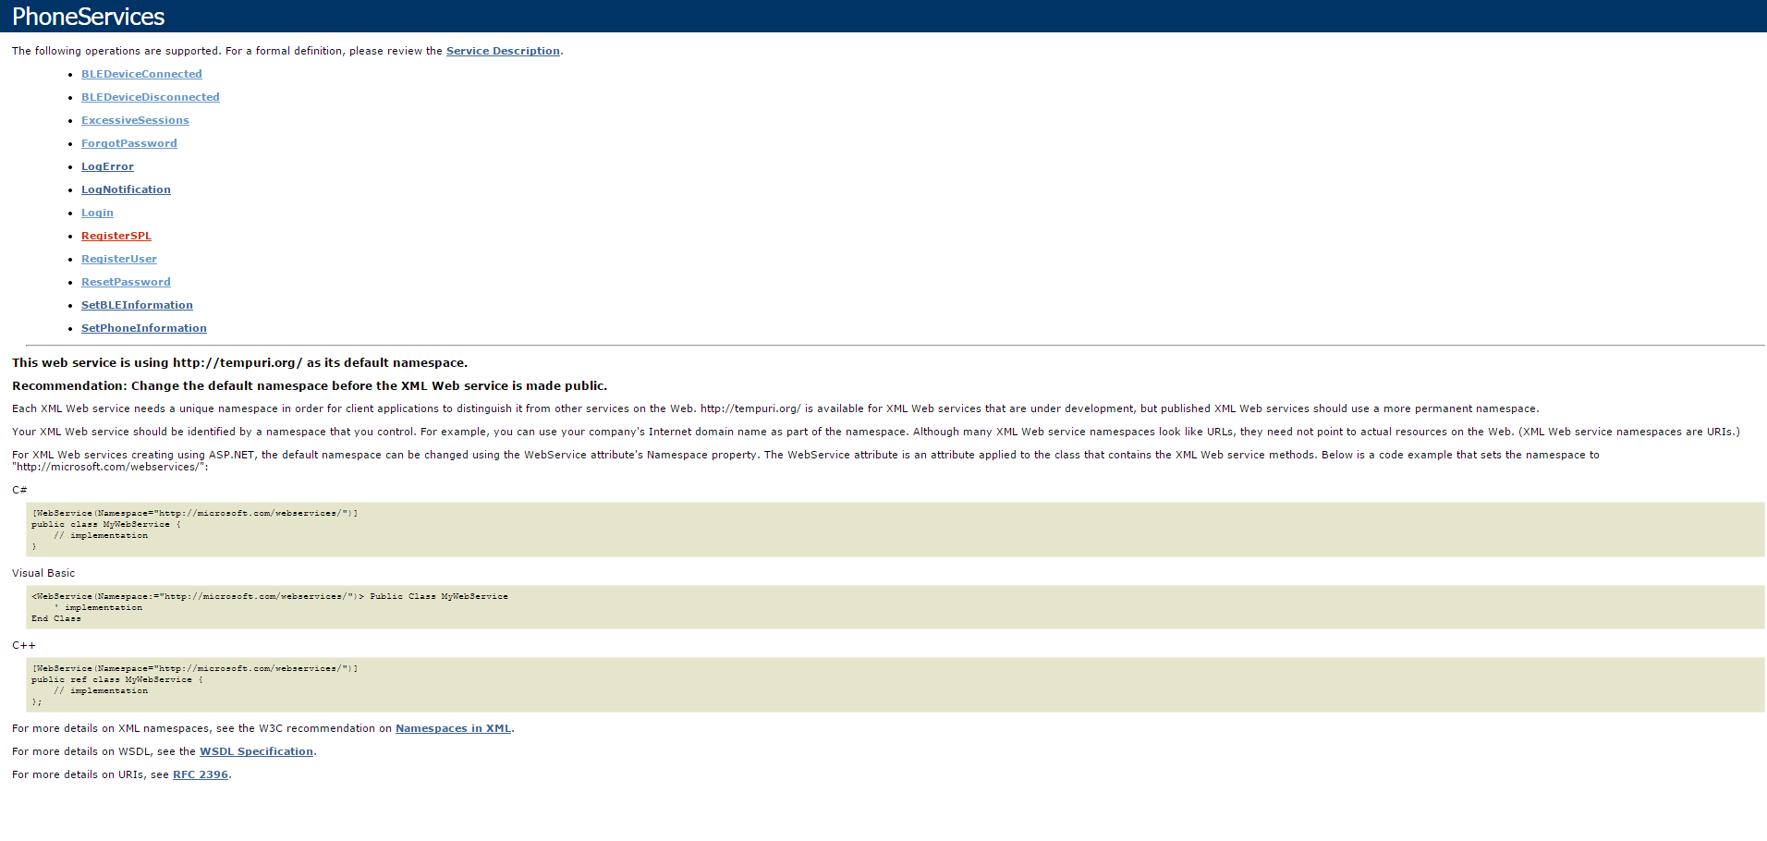
Fill out the information required by the web service.
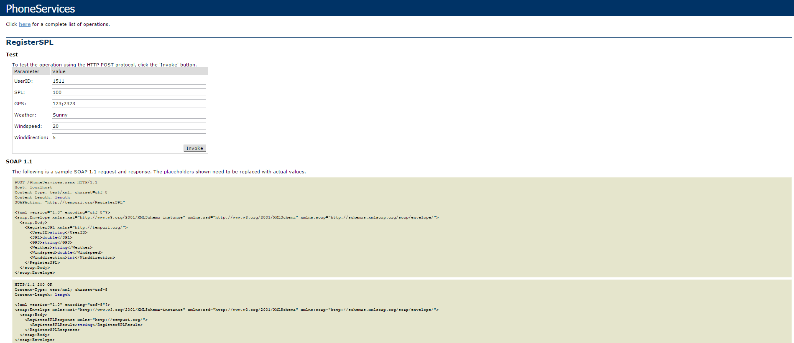
Receive answer.

In this case the subscriber had set that given that SPL value the vibration pattern would be “Fast Alert”.

Finally, the Safety Manager (who is the parent that is displayed in the following image) is notified.

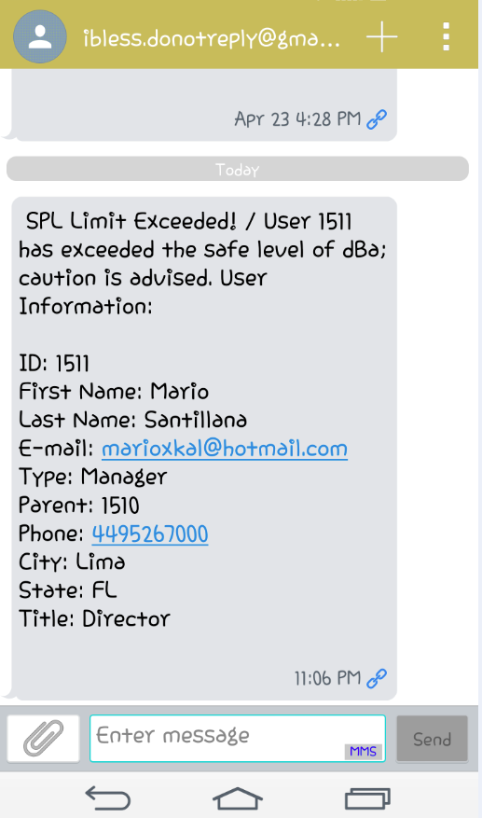

Notify BLE Device Disconnection

Choose BLEDeviceDisconnected in the emulator.

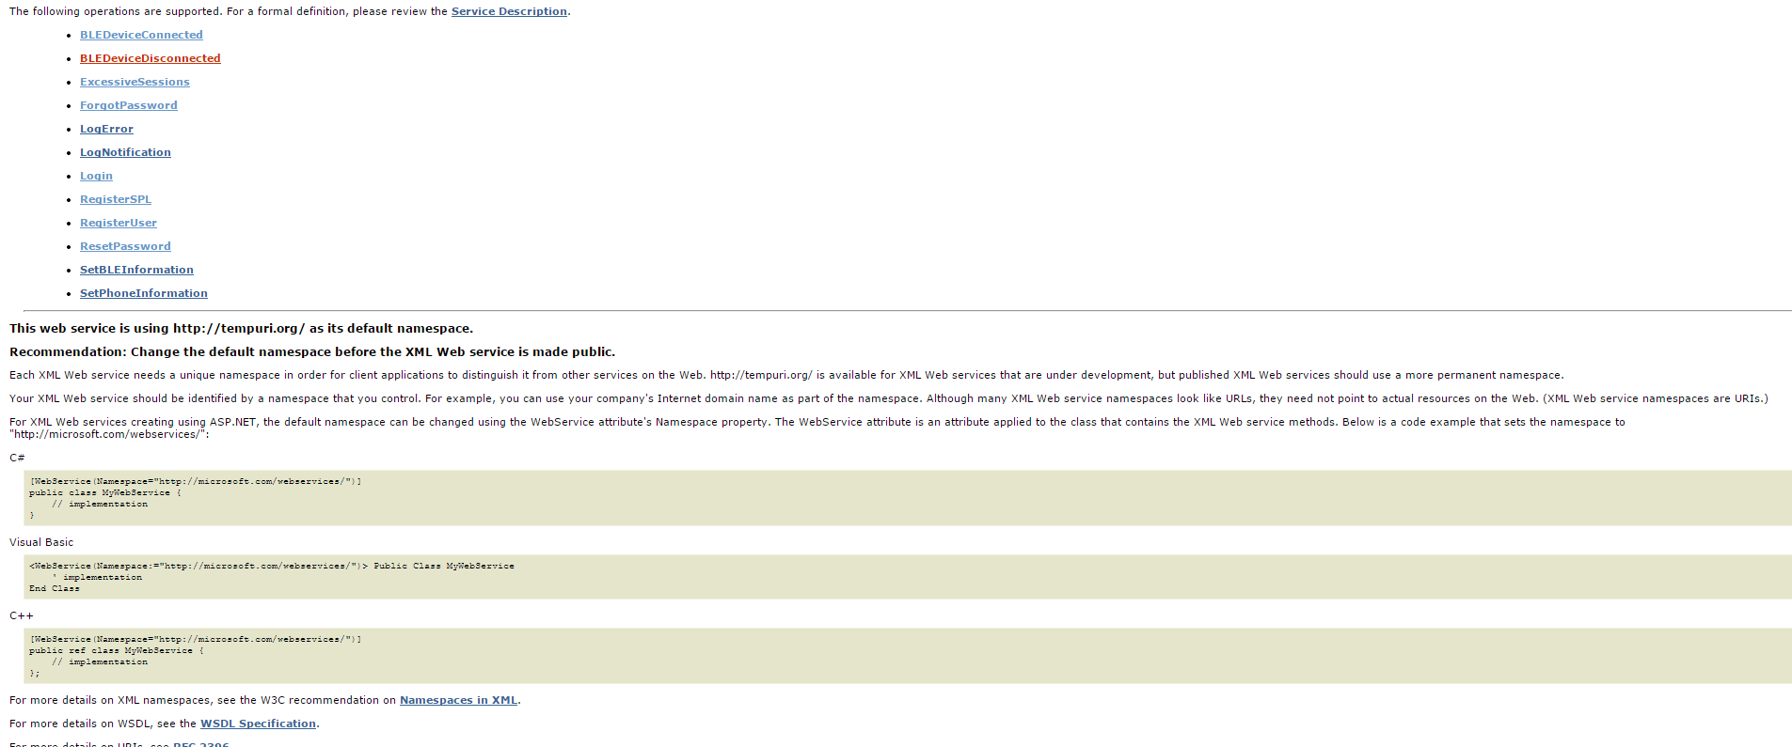
Fill out required information.

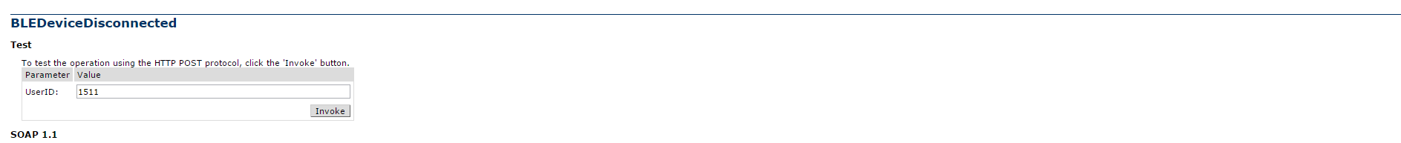
Finally, the safety manager is notified.

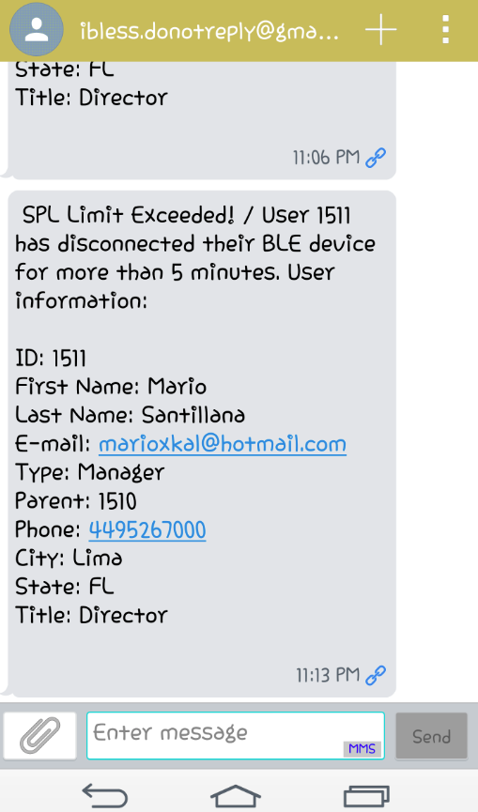

Notify BLE Device Connection

As usual select the BLEDeviceConnected service, and fill out the required information.

Here is a screen shot of the safety manager's reply.

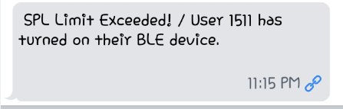

Notify Excessive Sessions

As usual select the ExcessiveSessions web service, and fill out the required information.

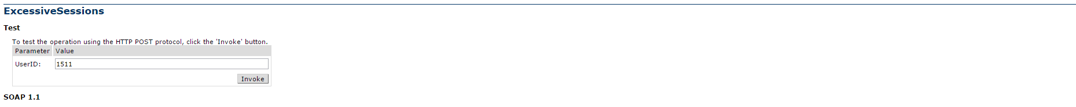
Here is a screen shot of the safety manager's reply.

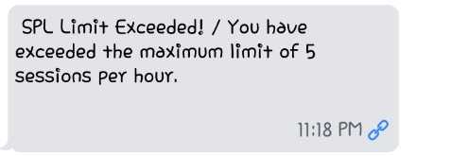

Notify Same Location

This use case cannot be used directly. It is the result of the Register SPL use case. If the user reports the same location when the SPL has been exceeded more than once, then this is executed. Here is a screen shot of the safety manager's notification.

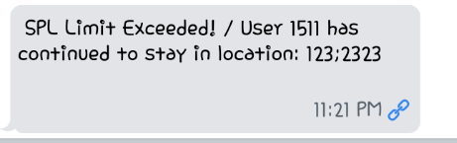

Login WS

Select the Login web service from the emulator, and fill out the required information.

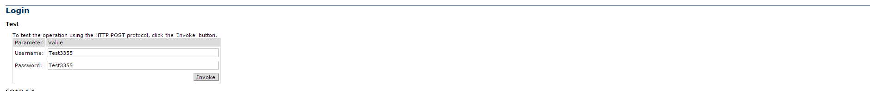
Here is the reply.

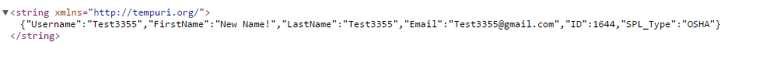
Reset Password

Select the reset password web service, and fill out the information.

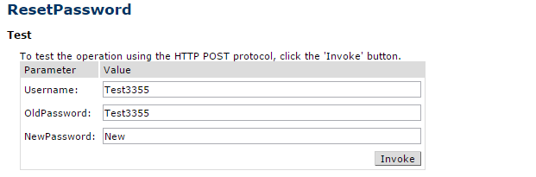

Register User

Select the register user web service, and fill out the information.

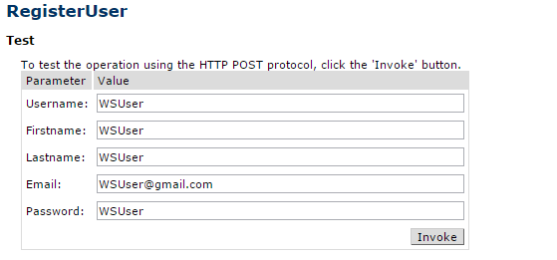
The reply will be true if no error, or false if error.

Set BLE Information

Select the set ble information web service, and fill out the information.

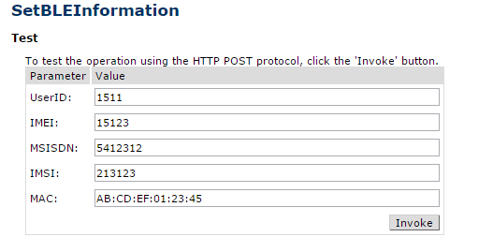

Set Phone Information

Select the set phone information web service, and fill out the information.

